**City parking assistant**

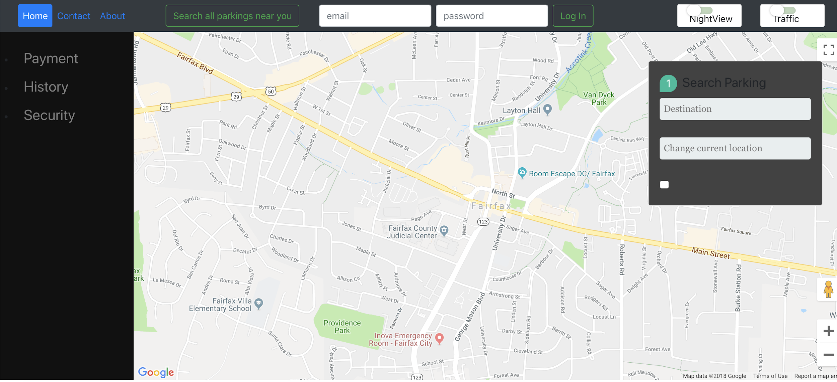

**Traffic information**

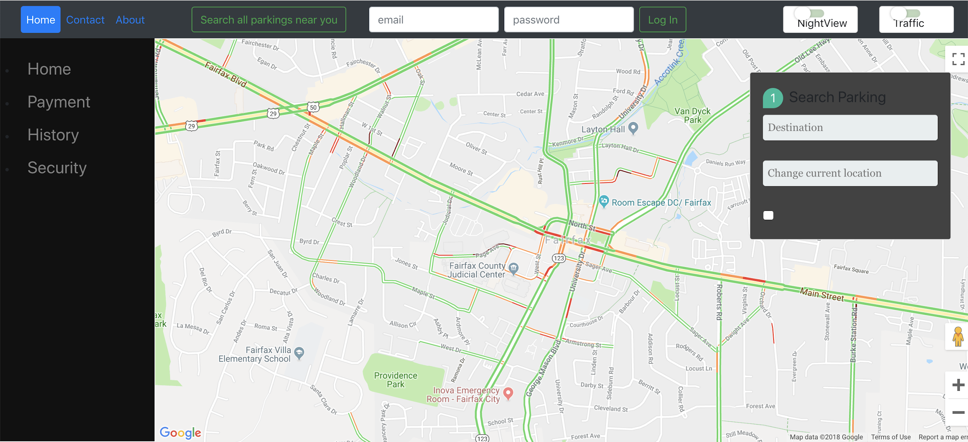

**Night mode on/off**

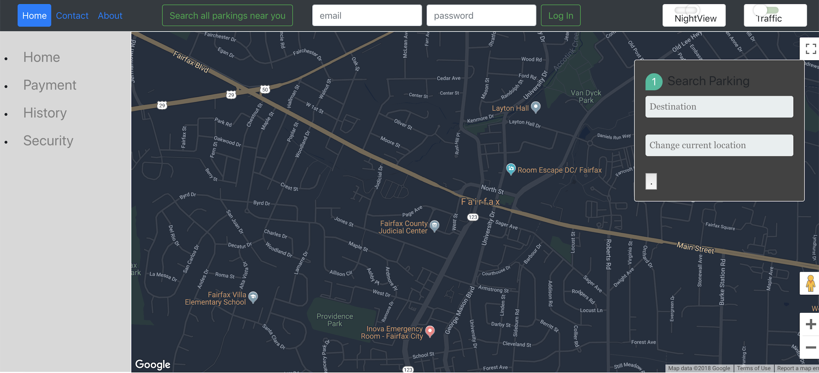

**Source to destination route**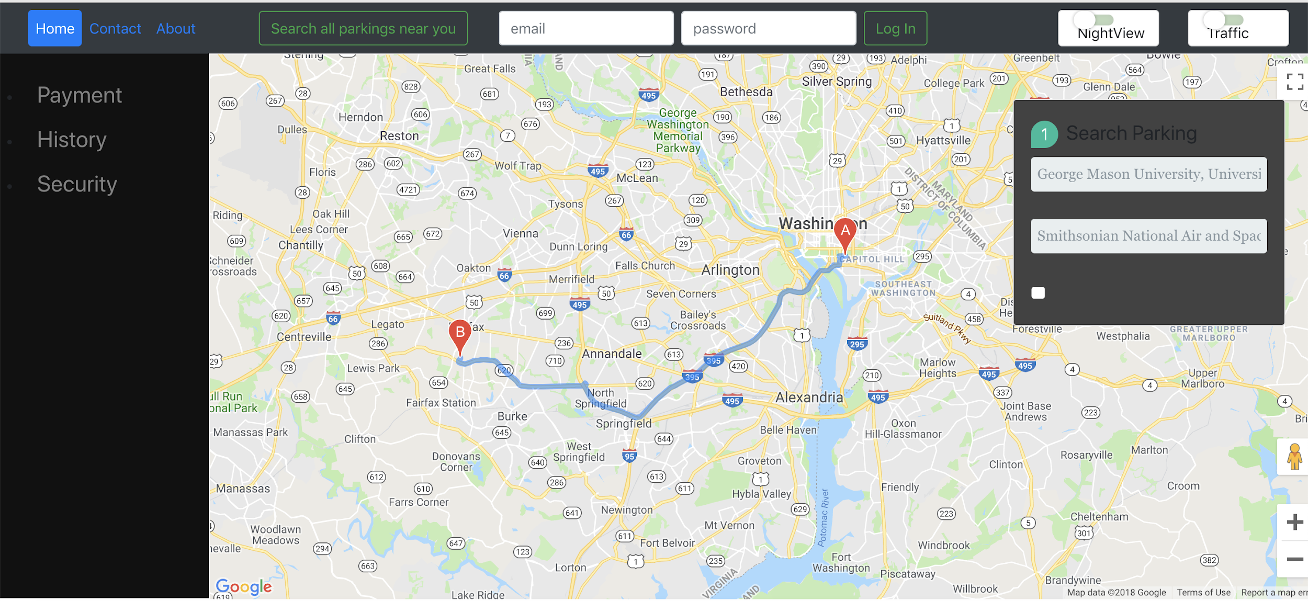

Parking places at your desired destination

* Displays parking spots with image of what the parking place looks like with exact location details

Search all parkings near you

* Manually listed parking spots near george mason university